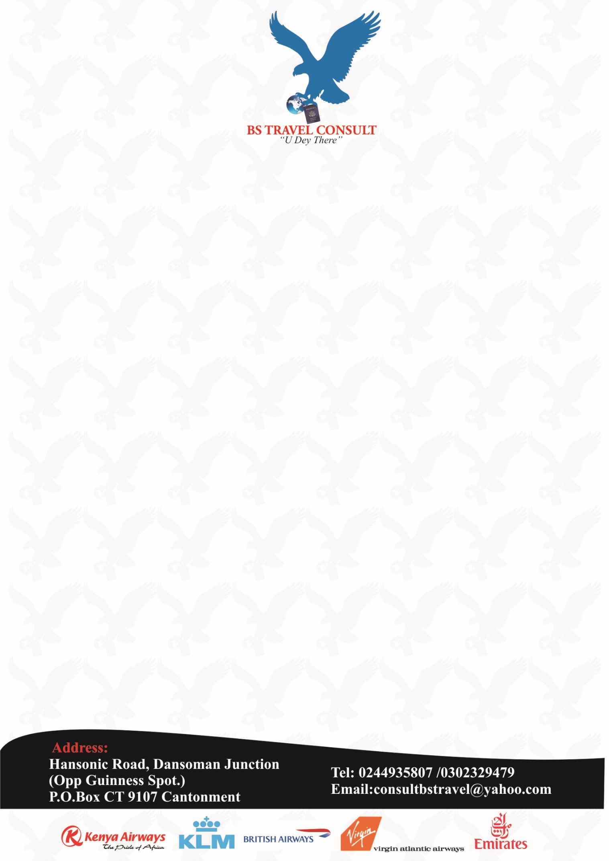

**TRAVEL MANAGEMENT PROPOSAL**

**Title:** Your Travel Needs Our Concern

**Organization:** BS TRAVEL CONSULT

**Incorporation:** February 2013

**CEO:** Barnabas Sackey

**Contact:** Email Address: consultbstravel@yahoo.com

Postal Address: P.O. Box CT 9107

Cantonments,

Accra,

Ghana

Main Line: +233 (0) 50 643 1469

Mobile: +233 (0) 24 493 5807

**Location:** Hansonic Road

Dansoman Junction

(Opp. Guiness Spot)

**Proposal idea:**

Assisting and advising in all of your travel needs. Be it ticketing, car rental, unaccompanied luggage, courier, visas, passports, emergency pickups, tours, travel insurance etc.

**Objectives:**

We are your One Stop Travel Agent. No need to engage various companies to handle your travel affairs.

**Users:**

The service is both for you as a corporate entity, as well as for your private needs. Terms and conditions will apply.

**Impact:**

* Less stress for you.
* Knowing one trustworthy and reliable agent is handling everything.
* No need to travel abroad to reach inner Ghana destinations.
* Compatible fares.
* Negotiated pricing, invoicing & payment terms.
* 24hrs availability.
* Just a phone call away.
* Small company giving you the much required attention.
* Keeping your travelers happy before, during and after their travels.

**Project duration:**

Indefinite.